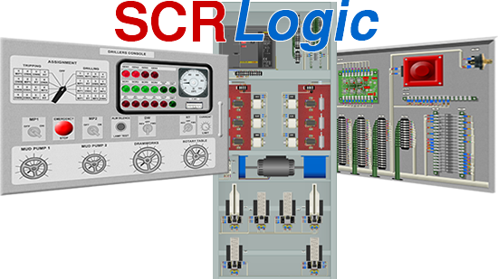

User Manual

Copyright ©2017 Contrelec Limited. All rights reserved.

TABLE OF CONTENTS

1 DISCLAIMER 4

2 INTRODUCTION 5

3 INSTALLATION 6

4 LICENSING 6

4.1 Purchasing On-Line 6

4.2 Purchasing Off-Line 6

5 QUICK START 7

5.1 General Operation 7

5.2 Fault Finding 11

5.3 Additional Tips 14

6 SCRIPTING 16

6.1 Example Scripts 16

6.2 Creating a New Script 16

Time Interval 17

Command 18

6.3 Editing an Existing Script 19

Adding Lines 19

Inserting Lines 19

Moving Lines 20

Deleting Lines 20

6.4 Simultaneous Events 20

6.5 Loading and Running Scripts 20

Loading 20

Running 21

Pausing 21

Correcting Faults 21

Finishing The Script 23

7 MENU COMMANDS 24

7.1 File Menu 24

Load Script 24

Script Writer 24

Print Faults 24

Exit 24

7.2 Training Menu 24

Fault Selector 24

Apply Selected Faults 25

Clear Faults (Keep Selection) 25

Clear All Faults and Selection 25

Fix Fault 25

Start Timer 25

Stop Timer 25

Reset Timer 25

Sound Mute 25

Auto Hide Meter 25

7.3 Help Menu 26

SCRLogic User Manual 26

Schematics 26

Enter License 26

About SCRLogic 26

Contrelec Web Site 26

8 FAULT FINDING TIPS 27

# DISCLAIMER

The contents of this manual are intended as a guide to using software provided by Contrelec Limited and in no way constitute, or should be construed as, an instruction for repairing or maintaining actual equipment.

By using the software you agree to the following:

Software provided by Contrelec Limited is provided 'as is' without warranty of any kind, either express or implied, including, but not limited to, the implied warranties of fitness for a purpose, or the warranty of non-infringement. Without limiting the foregoing, Contrelec Limited makes no warranty that:

1. the software will meet your requirements
2. the software will be uninterrupted, timely, secure or error-free
3. the results that may be obtained from the use of the software will be effective, accurate or reliable
4. the quality of the software will meet your expectations
5. any errors in the software obtained from Contrelec Limited will be corrected.

Software and its documentation:

1. could include technical or other mistakes, inaccuracies or typographical errors. Contrelec Limited may make changes to the software or documentation made available.
2. may be out of date, and Contrelec Limited makes no commitment to update such materials.
3. Contrelec Limited assumes no responsibility for errors or omissions in the software or documentation.
4. In no event shall Contrelec Limited be liable to you or any third parties for any special, punitive, incidental, indirect or consequential damages of any kind, or any damages whatsoever, including, without limitation, those resulting from loss of use, data or profits, whether or not Contrelec Limited has been advised of the possibility of such damages, and on any theory of liability, arising out of or in connection with the use of this software.
5. The use of the software is done at your own discretion and risk and with agreement that you will be solely responsible for any damage to your computer system or loss of data that results from such activities. No advice or information, whether oral or written, obtained by you from Contrelec Limited or from the Contrelec Limited web site shall create any warranty for the software.

# INTRODUCTION

SCRLogic is a software simulation package for training rig electricians to troubleshoot SCR systems which pre-date or have no PLC logic control.

Although it is based on a Hill Graham Controls land rig, the control philosophy is almost identical to Ross Hill and similar systems, and the fault-finding techniques learned by using the software can be applied to a whole range of equipment.

The software is built of two parts: the graphic representation of the system equipment, and a mathematical simulation of the analogue circuits. The student can probe terminals on the simulation screens and measure the voltage at each point. Faults can be applied to the circuit, which then allows the student to practice identification of faults by understanding the schematics and the observed measurements.

Faults can be introduced manually or from a pre-defined timed sequence of events controlled by a script running in the background. Scripts can be customised and saved and can create complex scenarios which will test the abilities of the most experienced technician.

The simulated system contains four SCRs, dual motor Drawworks, a Rotary Table and two parallel-motor Mud Pumps. Access is available to all four SCRs, the Drillers Console and Foot Throttle, blower MCC starters and the motor terminal boxes. Note that SCRLogic incorporates no generator control logic because the system complexity lies with the DC Motor and Auxiliary control circuits.

This program assumes that the user understands what an SCR system is, what it is used for and how it works, and is familiar with the terminology associated with a drilling rig. However, it could be used as a training aid to introduce SCR systems to electricians from an industrial or domestic background.

# INSTALLATION

The software is available as a free download from the Contrelec web site.

The software has complex calculations to perform to simulate the analogue circuitry, so a Windows (version 7 or later) PC with plenty of memory (at least 4Gb) and a powerful CPU will improve the user experience. The software will run on 32-bit machines, but these may experience memory problems due to memory fragmentation, so 64-bit is recommended. A mouse with a scroll wheel is required.

To install the software download the installation files from this link:

<http://www.contrelec.co.uk/pages/scrlogic>

This installs a demo of the version which has some features restricted (most notably scripting and a limited number of faults) and will time out after 20 minutes of use. To unlock all the features a full license is required.

# LICENSING

A license can be purchase in one of two ways:

## Purchasing On-Line

If this machine is connected to the Internet click the BUY LICENSE under   
Help🡪Enter License in the program and complete the payment details. Follow the payment instructions and, once complete, copy and paste the License File into the box provided under Help🡪Enter License. Click LICENSE to store the license.

## Purchasing Off-Line

If this machine can not connect to the Internet copy the Machine ID from   
Help🡪Enter License.

On a machine which is connected to the Internet follow this link:

<http://www.contrelec.co.uk/pages/scrlogic-buy>

and follow the payment instructions. Copy and paste the License File into the box provided under Help🡪Enter License. Click LICENSE to store the license.

Restart the program to complete the licensing process.

# QUICK START

## General Operation

On start-up the opening screen looks like this:

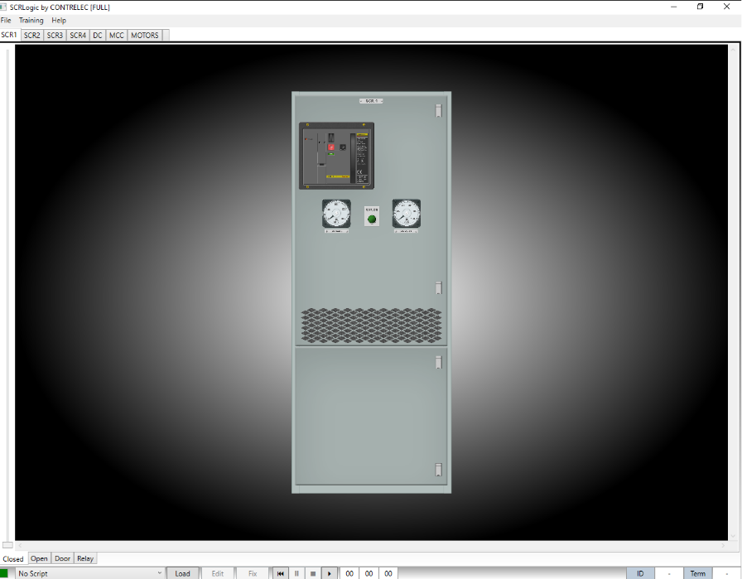

This shows SCR1 with the door closed.

Below the top menu bar are 7 tabs corresponding to the equipment which can be accessed. Below the image are tabs which reveal various views associated with the equipment. To look inside SCR1, click OPEN:

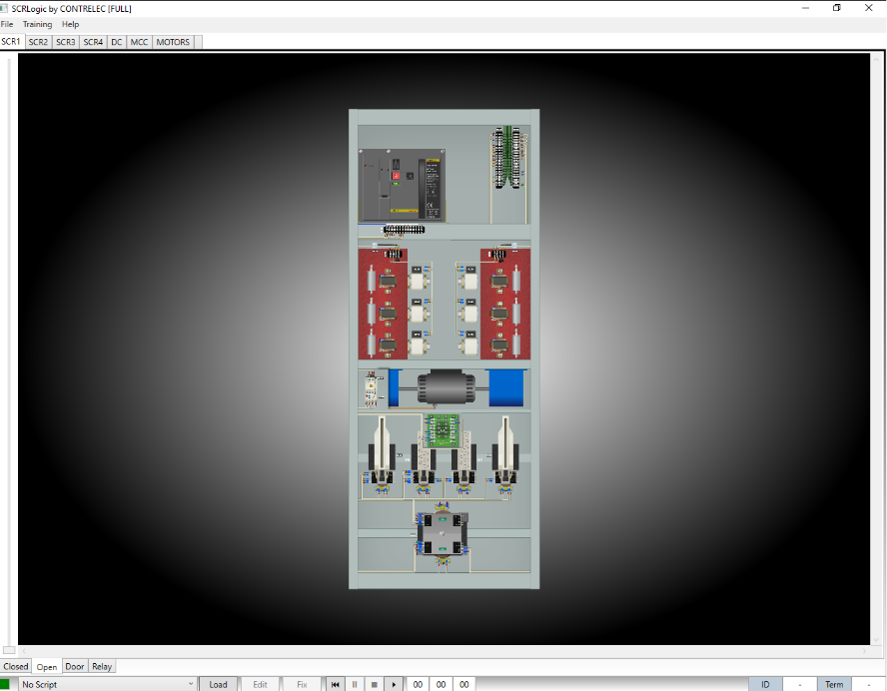

Now the SCR internal components are revealed.

The view can be zoomed in using the mouse wheel or by clicking and dragging the slider to the left of the display.

To look at a particular part of the equipment click and hold down the left mouse button and drag the view.

To control an item, such as closing a circuit breaker or operating a switch, the CONTROL key is used. To operate a pushbutton hold down the control key and left-click on the button. To close the SCR circuit breaker zoom into the circuit breaker, hold down the CONTROL key and click the I button. The circuit breaker will be heard to close, the blower will start and the SCR ON indication on the SCR door and Drillers Console will light up.

Navigate to the Drillers Console using the tabs at the top of the display:

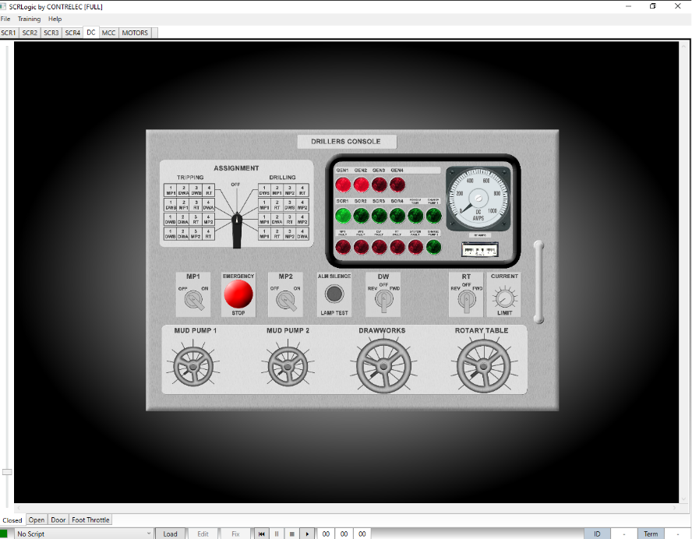

SCR1 can now be assigned to Mud Pump 1. The assignment switch is operated by holding down the CONTROL key and moving the mouse wheel up or down to move the switch anti-clockwise or clockwise respectively. Turn the assignment switch to a position which assigns SCR1 to Mud Pump 1.

Next, move the mouse over the MP1 OFF-ON selector switch. Hold down the CONTROL key and flick the mouse wheel up to turn the switch to the ON position. You will hear the blower MCC contactors close followed by the main SCR DC contactors.

Navigate back to SCR1 (Open) by clicking the SCR1 tab at the top of the display (and the OPEN tab at the bottom if not already selected). The Mud Pump 1 contactors (K2 and K7) can be seen to have closed as opposed to K1 and K6 which are open because the bar in between the auxiliary contact blocks has lifted.

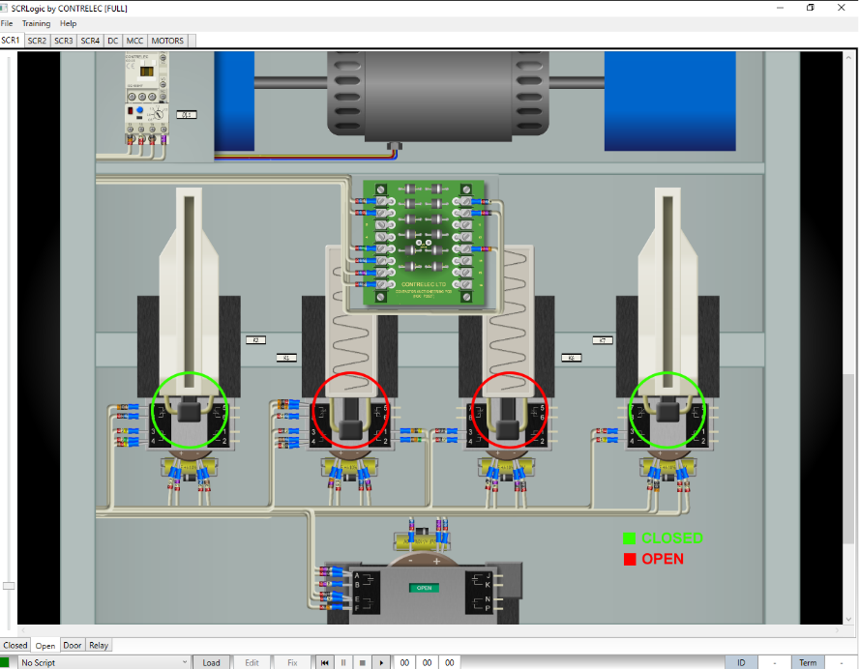

Note that the reversing contactor below (K5) has additional indicators for open and closed which don’t exist on the real thing. These have been added in the simulation because it is difficult to see which way this contactor is closed on-screen. This is one of several modifications which have been made to the appearance of objects to make working the simulation easier but in general every attempt has been made to keep the component images as true-to-life as possible.

Navigate back to the Drillers Console (Closed) screen. Place the mouse cursor over the Mud Pump 1 hand throttle. Hold down the CONTROL key and flick the mouse wheel up, and the handwheel begins to turn. As the handwheel passes the first scale mark the hand throttle microswitch will be heard to click, and Charge Pump 1 will start. Continue turning the hand throttle up to about half way.

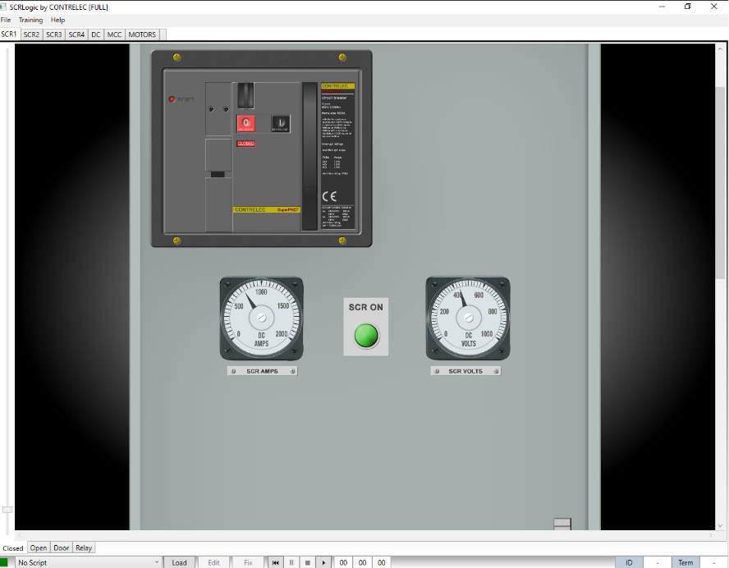

Navigate back to SCR1 (Closed) and note that the front panel SCR Amps and SCR Volts meters are indicating that the Mud Pump is running.

## Fault Finding

An essential part of troubleshooting is to be able to measure voltages at various points in the circuit. Zoom up on K7 and place the mouse cursor over the negative contactor coil connection.

The connection will highlight and the mouse cursor will change to a probe. In the bottom right hand corner of the screen the ID box will show K7 and the Term box will show [-] indicating that the terminal is K7-.

Click and hold the mouse right-hand button and a meter pops up showing the measured value. The meter is auto-ranging and auto-sensing, so will automatically switch range and AC or DC. Release the mouse button and the meter stays in place.

To make it disappear and re-appear on every probe check the Training🡪Auto Hide Meter option on the main menu. Probe the other terminals to get a feel for how this works.

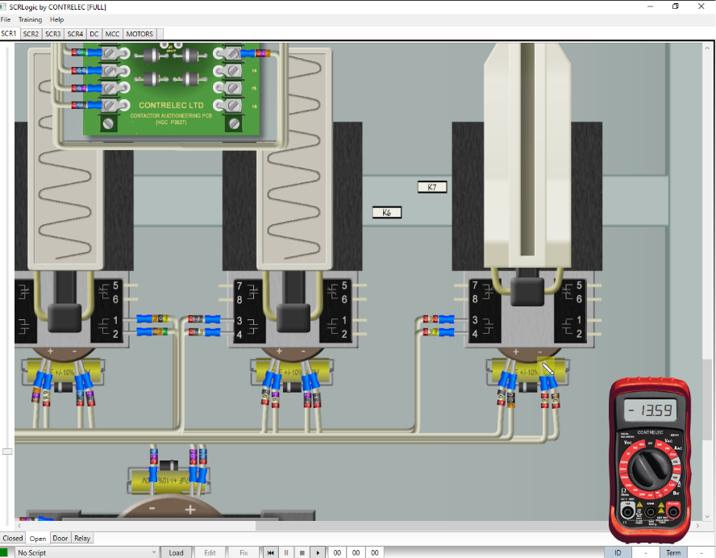

Now let’s try some fault-finding.

To troubleshoot the simulation you will need some schematics. Select Help🡪Schematics to open up the system drawing book, which is a PDF file which can be printed off for easier working (A3 recommended). The drawings are reproductions of the original system drawings for this project. Open the drawing book at drawing 6070D042 SCR Schematic.

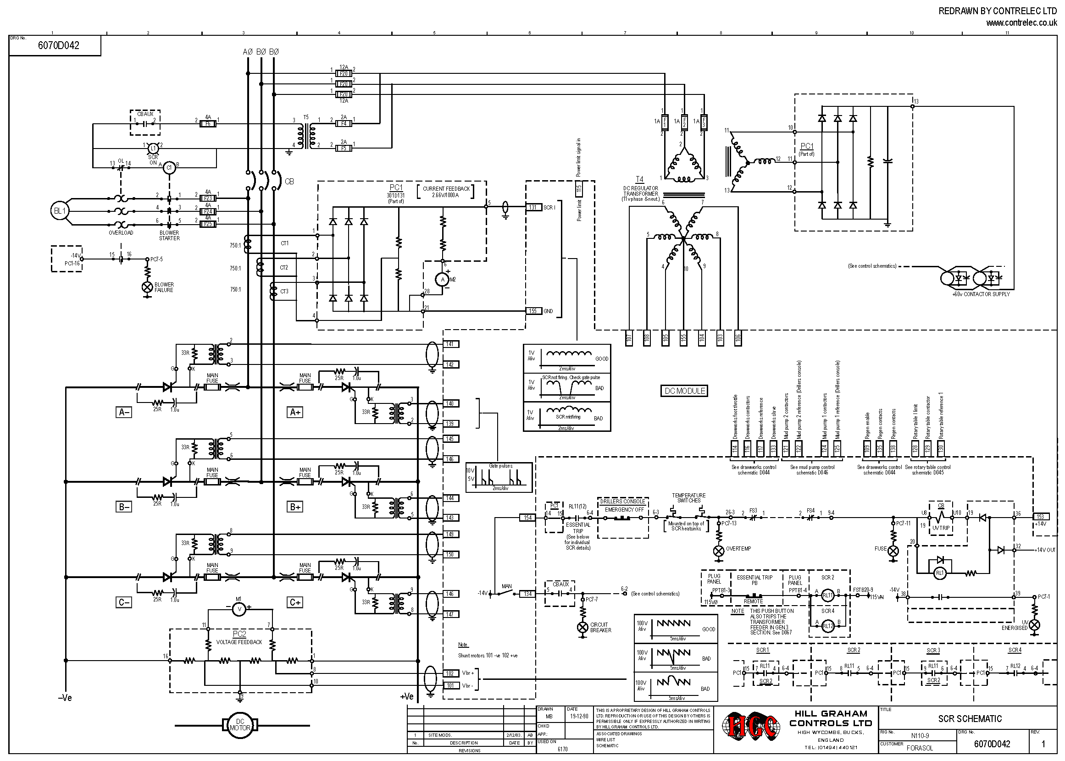

Follow pin 154 of the DC Module (the DC Module appears on the Door tab, bottom of screen) through to the circuit breaker UV coil and probe each point. Everything to the left of the UV coil should be around -14VDC, and everything to the right will be about +14VDC.

Select Training🡪Fault Selector, expand the SCR1 tab, then Temperature Switches. Check the TS2 temperature Switch box then click Apply. SCR1 circuit breaker will trip. Close the fault selector window by clicking Finished.

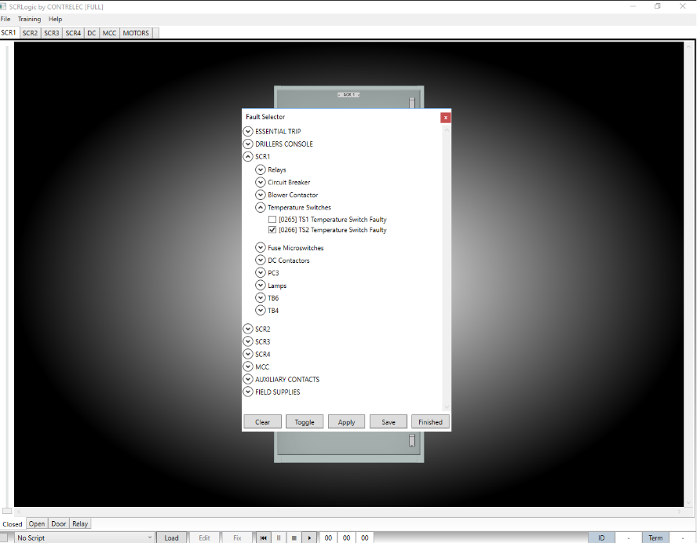

Follow pin 154 of the DC Module through to the circuit breaker UV coil and notice when the voltage changes from -14VDC to +14VDC. This will be at one of the temperature switches. Try and close the circuit breaker – it won’t close because the voltage either side of the UV coil is +14VDC.

The fault can be cleared several ways, but this time click Training🡪Fix Fault, expand SCR1 and Temperature Switches. Click the TS1 box and click Fix. The system will tell you that the wrong fault has been identified. Repeat the process but this time select the correct fault.

Once fixed, SCR1 circuit breaker can be closed gain. Once the breaker is closed the main contactors will close, but Mud Pump 1 will not run. Navigate to SCR1 (Door) and notice that the Zero Throttle Interlock is lit, and the SCR will not run until the Mud Pump 1 hand throttle on the Drillers Console is returned to zero, just like the real thing.

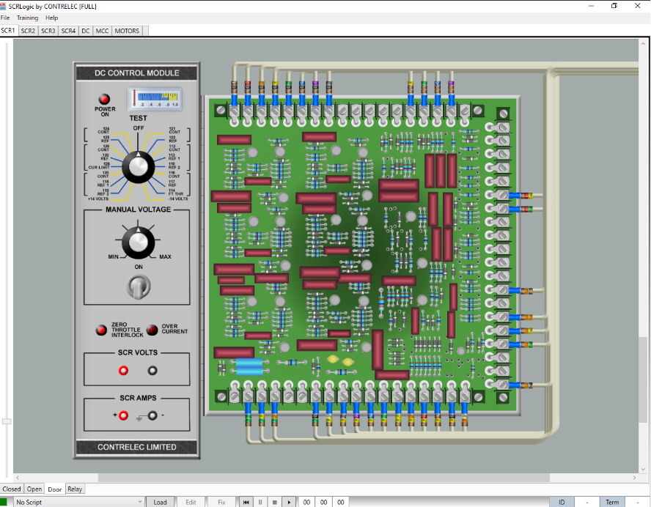

Note that all the DC Module front panel controls work, including the diagnostics meter and switch and manual control. The module itself is one of the components which is represented graphically in a way which makes working the simulation easier.

Using the manual fault setting facilities a supervisor can guide a student through the fault finding process. The scripting facility allows simple or complex scenarios to be prepared. Scripting is only available with a FULL license.

## Additional Tips

Please read through these notes:

Moving Between Locations

When fault-finding remember that moving between the Drillers Console and the SCR room is quick in the simulation, but a lot slower in real life. Practice your fault finding with this in mind.

Drillers Console Assignment Switch and Pots

The Drillers Console (Door) screen shows the assignment switch and hand throttle potentiometers ‘stacked’. The hand throttles have front and rear pots (and microswitches), so to access each one CONTROL-click the FRONT/REAR selector adjacent to the pot. Note that the pots can be rotated from the rear as well.

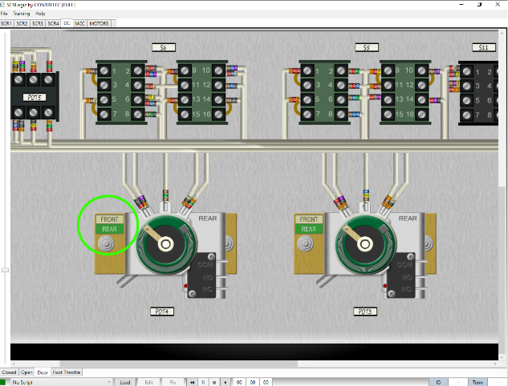 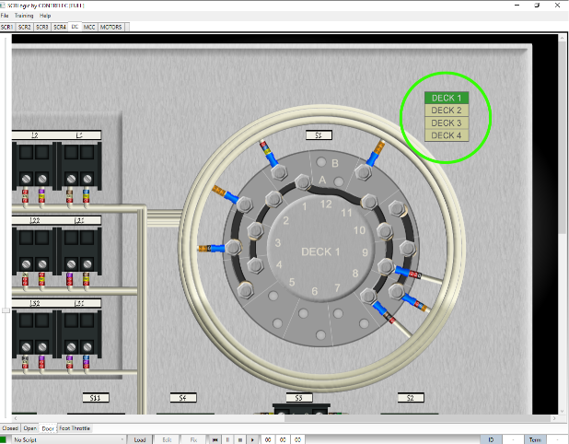

Similarly the assignment switch has 4 decks (one for each SCR) and these are selected by CONTROL-clicking the corresponding selector. The assignment switch has also been graphically flattened to make accessing the terminals easier in the simulation

Drillers Console and MCC Pushbuttons

Unlike the circuit breaker pushbuttons, these require a CONTROL-click to set and a CONTROL-click to release. This is to allow fault finding to be done with the button pressed.

Processing Indicator

In the bottom left-hand corner of the screen is an indicator showing the status of the simulation. During normal operation the indicator flashes green/grey, but if the simulation fails it will turn red, and may require a program restart.

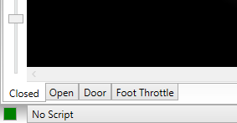

Certain operations, such as assigning the Drawworks, involve complex recalculation of the circuit, and (depending on computing power) the indicator may be greyed out longer than usual and controls may not respond for a short while.

Multiple Faults

Take care when introducing multiple short-circuit faults. The simulation can be forced into an unresolvable configuration when power supplies are short-circuited together.

Fault List

A complete list of available faults can be obtained for reference by selecting File🡪Print Faults. Note that the number of faults available under a DEMO license is limited.

Sound Mute

The program sound effects can be silenced by selecting Training🡪Sound Mute

# SCRIPTING

Holders of FULL licenses can write, load and run scripts.

Scripts are pre-programmed sequences of timed events. An event can be an instruction, alert, fault set or fault fix. Once written they can be loaded and run to create complex fault scenarios for students.

## Example Scripts

A number of scripts are provided as standard:

Name Description

SCRIPT-001 SCR1 Trip

SCRIPT-002 Mud Pump 1 Assignment Fault

SCRIPT-003 Drawworks Assignment Fault

SCRIPT-004 RT Pot Fault

SCRIPT-005 All the above applied sequentially.

## Creating a New Script

Scripts are created and edited using the Script Writer which is accessed by selecting File🡪Script Writer. Note that for the Script Writer to be available no script must be running.

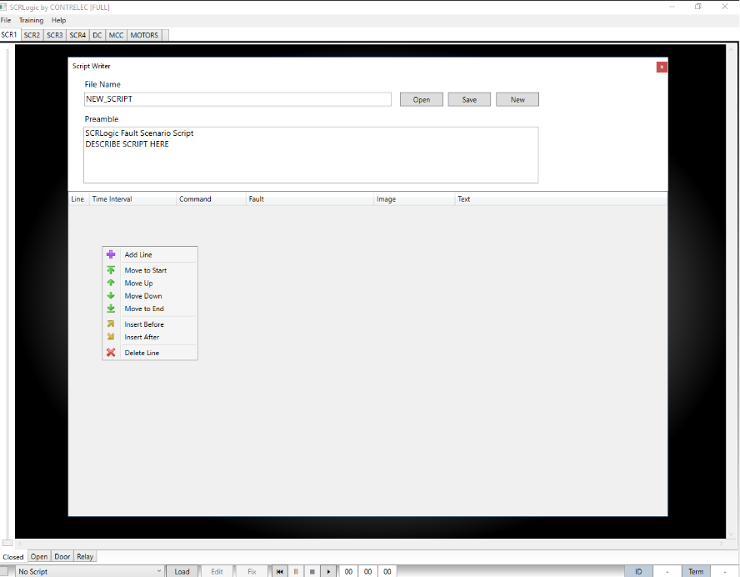

It is recommended to create a new script by editing an existing one and saving under a new file name, but to start from scratch opens with the default script template which contains only the file name and a dummy header.

Enter the script File Name and some descriptive text for the Preamble. The Preamble is never visible when the script is run, so details about the script can be explicit.

Below the Preamble box is an empty table which will list the script events. To create a new event, right-click in this area and select Add Line to create a new event line. Continue to add lines in this way to build your script.

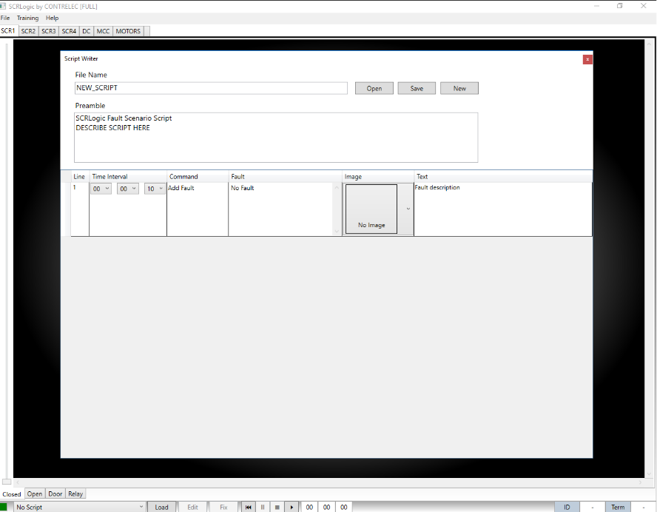

Once complete, save the script by clicking SAVE.

The contents of each line are as follows:

### Time Interval

This sets the time delay between the previous event and this one. For example, a Time Interval of 15 seconds in the first event means that the event will not occur until 15 seconds after the start. Time Intervals of zero are permitted to allow several events to occur at the same time.

### Command

There are four basic commands, which can be selected from a drop-down list:

* Instruction (requires resume)  
  This displays a message box, and is use to provide instructions to the user on things like how to set up the simulator before starting, what to do next. It also pauses the script to allow longer messages to be read, so the user must click the PLAY/RESUME button in the script transport controls at the foot of the screen.



* Message  
  Similar to an Instruction except that the script is not paused.
* Add Fault  
  Allows a fault to be applied to the system.
* Fix Fault  
  Allows a previously applied fault to be ‘fixed’.

Fault

In association with the Add Fault or Fix Fault commands a system fault can be selected from an expandable, categorised list of available faults. The faults are pre-set within the program and can not be altered. This setting is ignored with the Instruction and Message commands.

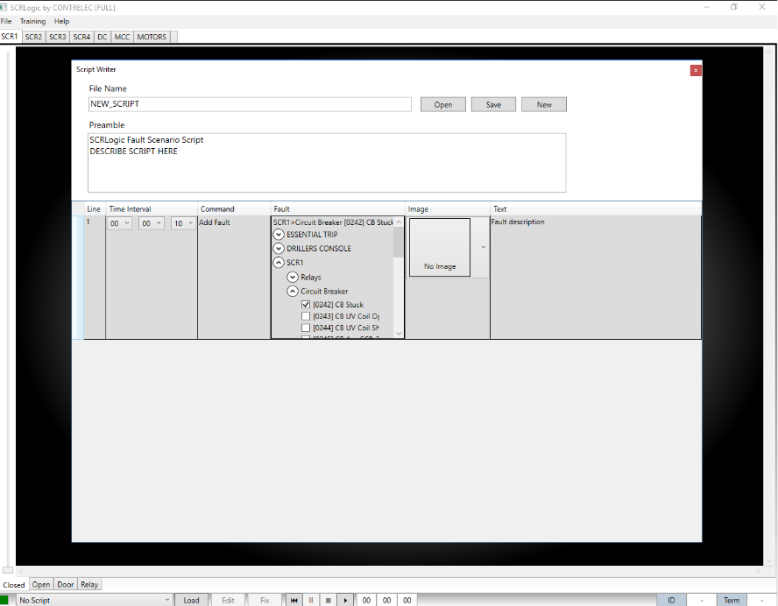

Image

An image can be selected from a small library to be displayed alongside the message which appears for as events occur. For no image, select No Image. This setting is ignored with the Add Fault and Fix Fault commands.

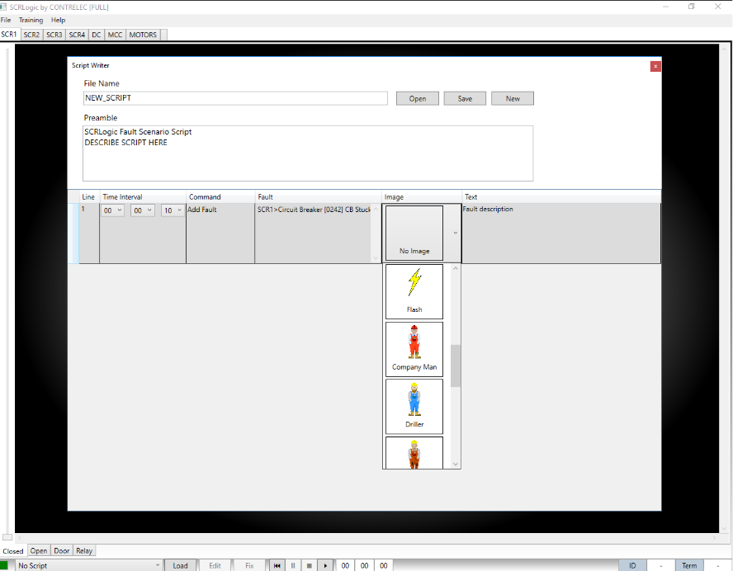

Text

In association with the Instruction and Message commands, the text to be displayed is entered here. Plain text or HTML (for better formatting control) can be entered. To display no text (i.e. for simultaneous events or ‘quiet’ faults) leave this box empty.

## Editing an Existing Script

To edit or modify an existing script, open the Script Writer (File🡪Script Writer) and click the OPEN button. Using the file browser navigate to the required script, select it then click OPEN. Note that for the Script Writer to be available no script must be running.

The contents of each line can be altered individually, but to add, insert, move or delete lines access the menu by right-clicking the script line area:

### Adding Lines

To add a line at the end of the script right-click the script line area and select ADD LINE.

### Inserting Lines

Lines can be inserted above or below the selected line.

Select a line, them right-click and select either Insert Above or Insert Below as appropriate.

### Moving Lines

Lines can be moved to the top of the list by right-clicking the line and selecting Move to Top. Similarly, a line can be moved to the end by right-click🡪Move to End.

To move a line up or down one step at a time, right-click then select Move Up or Move Down as required.

Lines can also be moved by left-clicking and dragging into position.

### Deleting Lines

To delete a line right-click it and select Delete Line from the menu.

## Simultaneous Events

Events can be set to occur simultaneously by entering a time interval of zero between them. For example, to make 3 events occur after an interval of 5 minutes from the previous event, give the first event an interval of 5 minutes but give the next two event a time interval of zero.

This means that the first event will occur after an interval of 5 minutes, and the next two immediately afterwards.

With simultaneous events, you may only require a single message to the user, so leave the first two text boxes blank and enter your message in the third event text box.

Demo SCRIPT-001 has an example of simultaneous events (events 2 & 3).

## Loading and Running Scripts

### Loading

A script must be loaded before it can be run. Please note that loading a script is not the same as opening it for editing in the Script Writer.

To load a script, select File🡪Load Script or click the Load button at the foot of the screen. Select the script to be loaded from the File Browser, and once loaded it will appear as an option in the Script Selector at the foot of the screen.

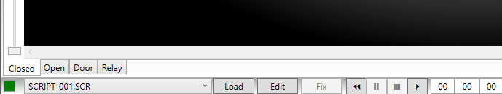

Note that, with a script loaded, the Edit button becomes available, and can be used to open the Script Writer to make changes to the script.

Any number of scripts can be pre-loaded in this way, and each one can be selected for running from the Script Selector

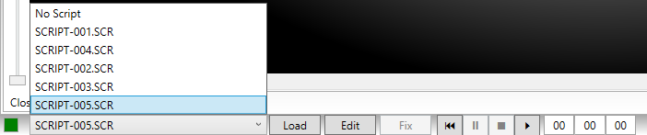

### Running

To run a script first select it from the loaded scripts in the script selector then click the Play/Resume button in the script transport controls at the foot of the screen. To ensure a script runs from the beginning click the Rewind button first.



When a script is running the time counter at the foot of the screen increments, and messages will appear or faults will be applied in accordance with the scripted instruction. One of the script commands, Instruction, pauses the timer to allow the user to take actions as instructed. Once complete the Play/Resume button must be clicked to restart the timer and complete the remainder of the script.

### Pausing

A script can be paused at any time by clicking the Pause button in the transport control.



Stopping

A script can be terminated by clicking the Stop button in the transport control. Note that stopping a script does not automatically clear all outstanding faults. To clear all remaining faluts click Training🡪Clear All Faults



### Correcting Faults

As the script runs, one or more faults will be introduced which must be identified using a systematic method of fault finding. Not only must the faulty component be identified, but the nature of the fault must be determined (i.e. short circuit, open circuit, stuck).

Once the user is confident that the fault has been identified a fix can be applied by clicking the Fix button. The exact fault must then be identified from the expanding list of faults available. If a fault is correctly identified the program will confirm this and an internal fix applied.

### Finishing The Script

The script will announce when all commands have been executed all faults fixed.

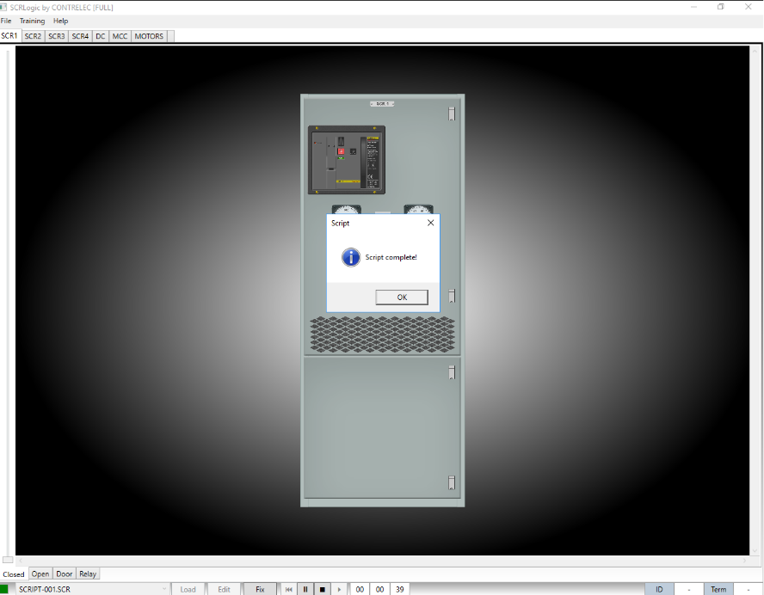

# MENU COMMANDS

## File Menu

### Load Script

Scripts must be loaded before they can be run. This option opens the File Browser to choose a script to load for execution. To edit or create a script, see the section on Scripting.

### Script Writer

The Script Writer is an editor for creating and modifying scripts. Refer to the Scripting section for more details.

### Print Faults

This option provides a structured text file of all the faults available within the program which can then be saved and printed.

### Exit

Closes all windows and exits the program.

## Training Menu

### Fault Selector

The fault selector is used to manually select and apply faults.

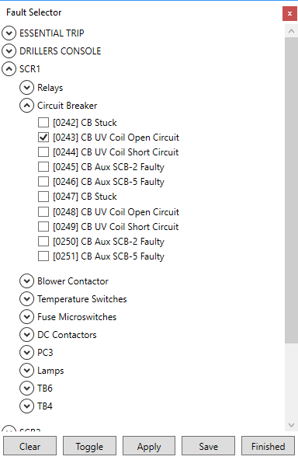Faults are grouped and categorised into expanding sections. To open or close a group or section, click on the expander button.

Faults are selected by clicking the check box, and fixed by un-checking, but the action is not performed until the Apply button is clicked.

The Clear button clears all selections and applies fixes to outstanding faults.

The Toggle button inverts the selection. The selection is not applied until the Apply button is clicked.

Save will store the current fault selection but will not apply it.

Finished closes the window but does not save the current selection or apply it so these actions must be performed before closing the window.

### Apply Selected Faults

This applies the fault scenario currently selected in the Fault Selector

### Clear Faults (Keep Selection)

This fixes all faults currently applied but does not clear the selection in the Fault Selector so it can be re-applied later if required.

### Clear All Faults and Selection

This option fixes all faults and clears the selection in the Fault Selector.

### Fix Fault

Opens the Fault Selector in to fix a fault. Only one fault can be selected for fixing and the program will confirm if the fix was successful. To fix more than one fault at a time use the Fault Selector option.

Fix Fault is intended to be used by trainees during an exercise or when running a script.

### Start Timer

Starts the script timer running. The timer can be used without running a script as a performance measure when tracing manually applied faults.

### Stop Timer

Stops the timer and consequently the current script if loaded and running.

### Reset Timer

Stops the timer and consequently the current script if loaded and running.

### Sound Mute

Mutes all sound effects when checked.

### Auto Hide Meter

Automatically hides the meter when not being used. To keep the meter visible all the time un-check this box.

## Help Menu

### SCRLogic User Manual

Opens a PDF version of this manual.

### Schematics

Opens a PDF book of the schematics associated with this simulation.

The schematics are a selection from an actual Hill Graham Controls project and have been redrawn by Contrelec for improved readability.

### Enter License

Use this option to obtain the machine ID and enter the license file obtained by purchasing from the Contrelec web site. Refer to the section on Licensing for more information.

### About SCRLogic

Displays information about the program version.

### Contrelec Web Site

Opens a browser at the Contrelec web site (<http://www.contrelec.co.uk>)

# FAULT FINDING TIPS

Here are some tips for safe, fast and efficient fault finding:

Be Safe

Always work safely with suitably rated equipment. Handheld meters should be rated at least up to 1000VDC and the probes should be similarly rated and in good condition.

Understand the Circuit

There is no substitute for a good understanding of how the circuit SHOULD work. Study the schematics or seek further training to improve understand.

Check Your Instruments

Although not an issue with this simulator in real life faulty instruments can waste time. Check also that the coloured leads are correctly inserted and in the correct connection points for the type of measurement you are taking (i.e. not crossed or in the wrong place). Always check the polarity of DC readings. Don’t assume that because you see 14V it is minus 14V, or vice versa.

Methodical Approach

Work methodically through the schematic and make NO ASSUMPTIONS. Disregard any pre-conceptions about what might be wrong. This simulation makes it easy to move between the drillers console and the rig floor. In reality this is time consuming and inefficient. Take as many measurements as possible from one location to pinpoint the location of the fault.

Make Notes

Make notes of measurements on a copy of the schematic. This will save time and remove guesswork from the process.

Fix the Obvious

If something is obviously wrong fix it first. This may seem obvious except you may be pursuing what you think is an unrelated fault but another obvious fault might be affecting your ability to be able to pinpoint the fault you are pursuing.

Keep Records

Records of faults are extremely useful for identifying repeat failures and components which may be under-rated. They can also be useful as a short cut when tracing new faults, but don’t be unduly influenced. The methodical approach will always get to the root of the problem.